**Pizza Detection**

**I annotated images in roboflow.There are two classes such as pizzabase and peppronipizza.I used yolov8 model for training and detected accurately.**

**See results to view how model is performing.Below are results on test dataset.**

**I used ultralytics for library import.**

**I converted data into yolo format using roboflow.**

**I use data.yaml file for training with 25 epochs on google colab.**

**Training took too much time on google colab.**

**I computed logs,plots,inference using roboflow** and ultralytics too.The ultralytics library was imported.I detected pizza with training in roboflow too . from ultralytics import YOLO and performed detection.

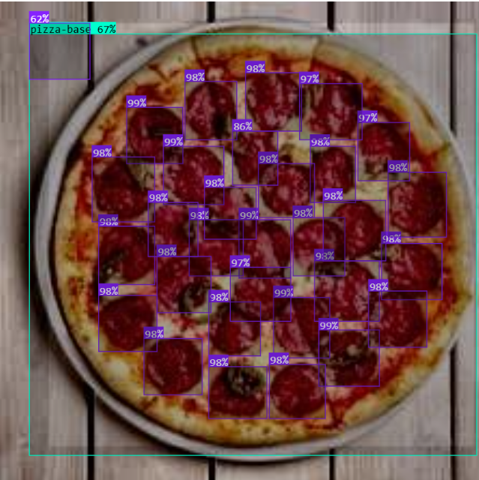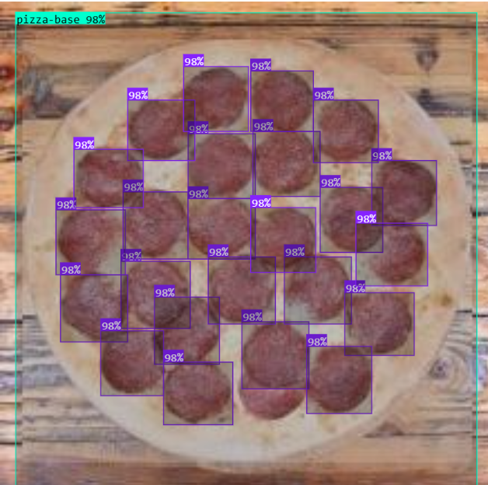

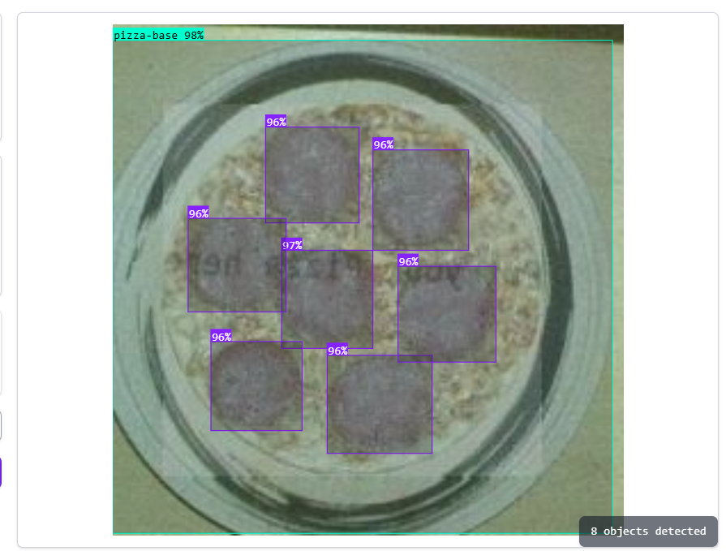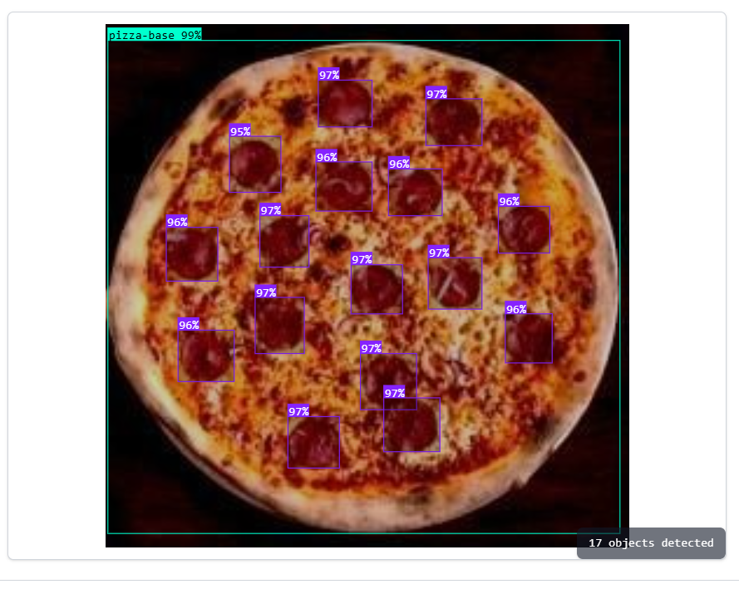

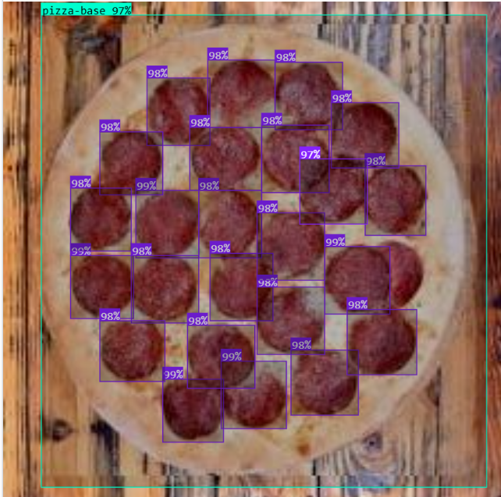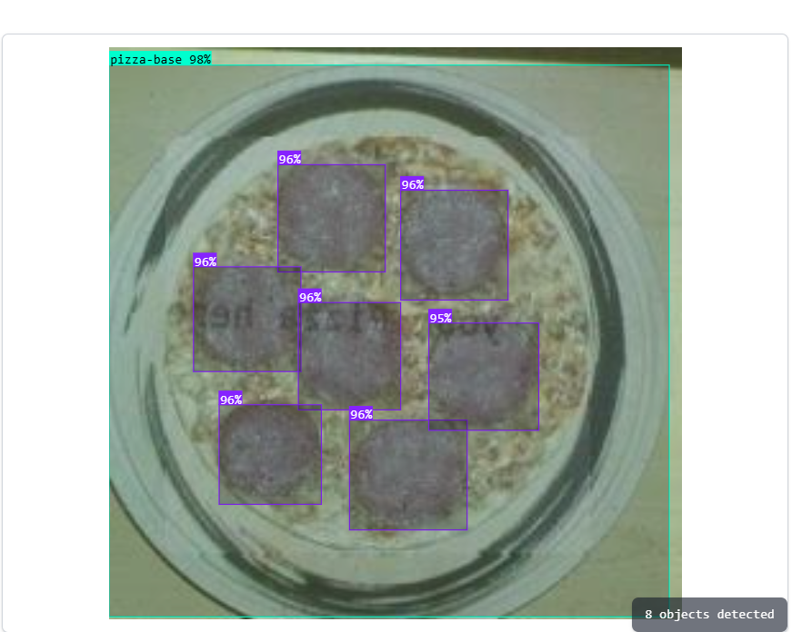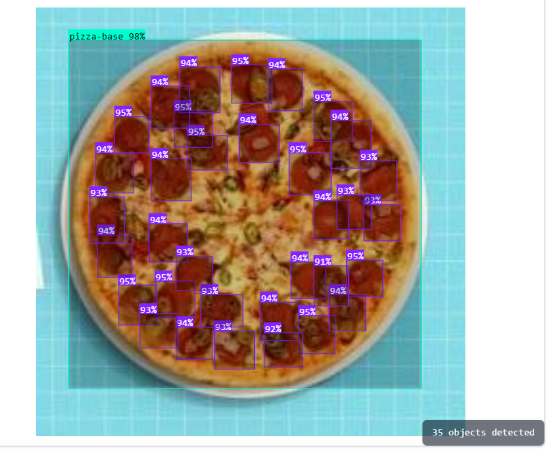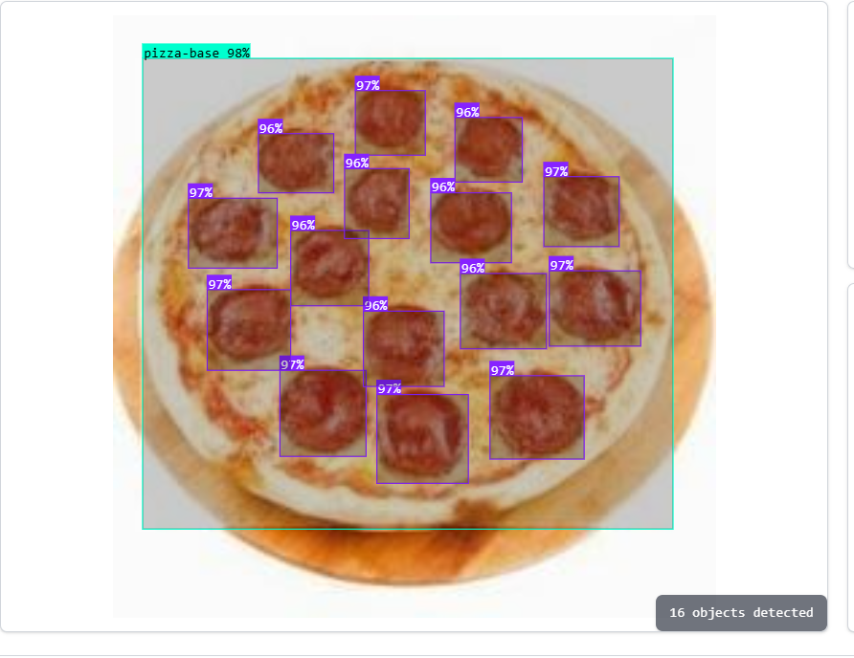

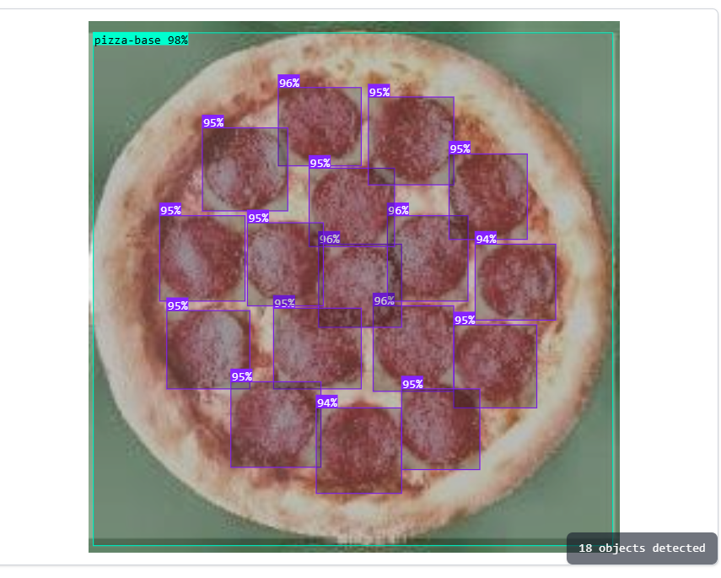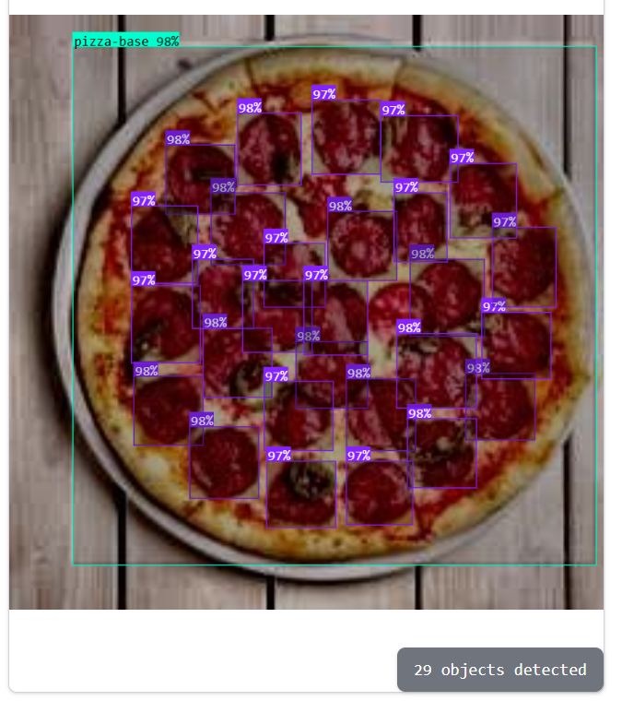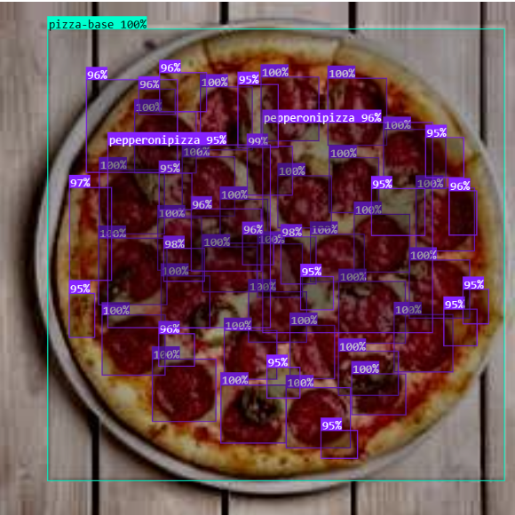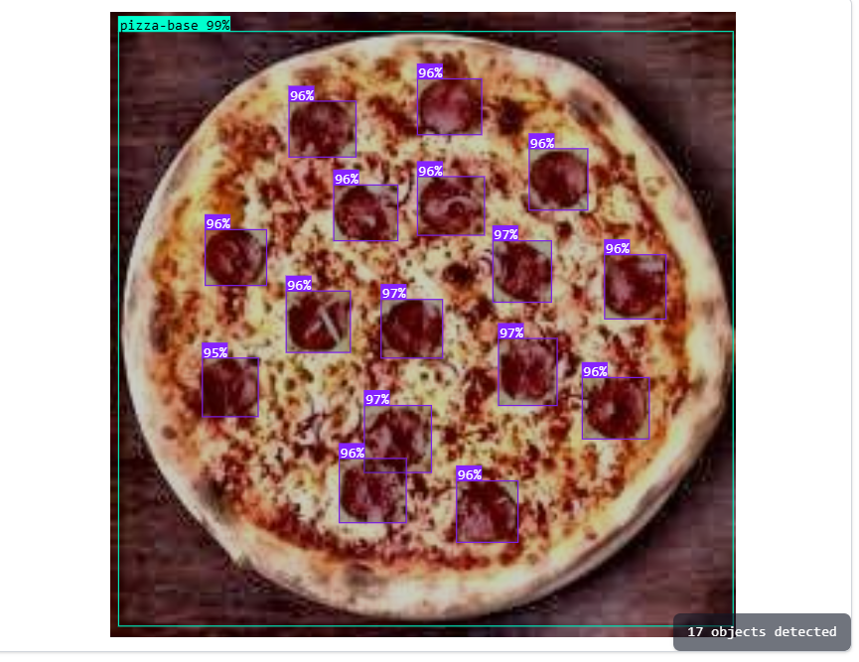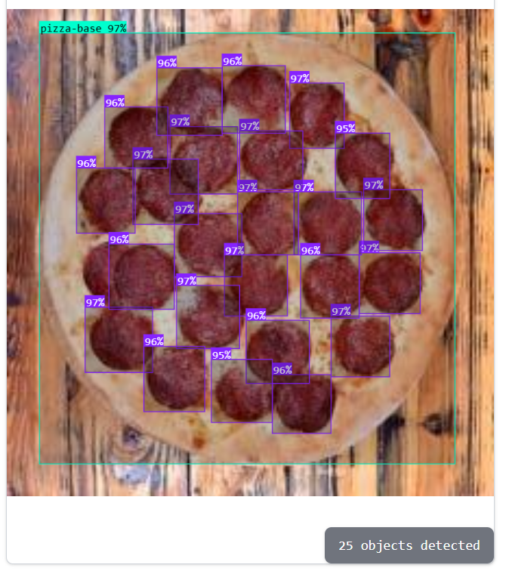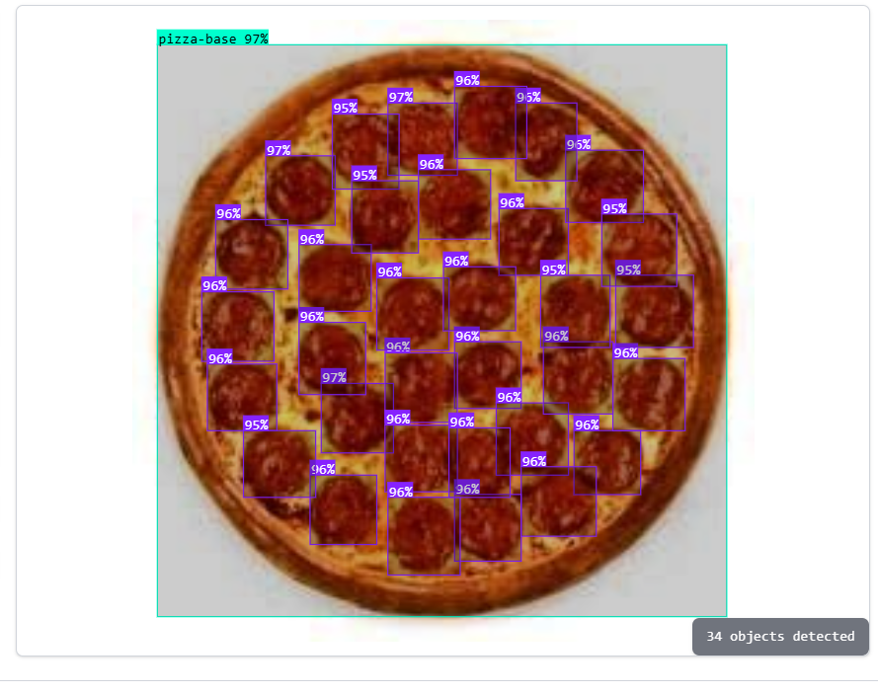

**What I have concluded from results :**

I have concluded that yolov8 performs well on pizza dataset.The model gives good score such as 97%,98%,99%,100% accuracy.It also detects pepperoni with good scores.It also detects pizza base with good scores.It is performing well and all plots are also proof that this model is performing well .With 95% confidence threshold ,overlap threshold 50 and opacity threshold 75 the model is performing well and yields good score.The model has capability to perform well even if I change confidence threshold and overlap threshold.The variations in threshold and confidence threshold allow to perform well.The bounding boxes are correctly locating the pepperoni on pizza base.

**Key Conclusions from Your Results**

Model Performance Excellence: MAP ,RECALL AND PRECISION ARE GOOD SCORES.These performance parameters are excellent and shows how accurate model is.The model performs excellent if we observe such scores and shows how effeicent model is performing.The results which are displayed in form of graphs ,plots shows excellent performance.The average mean precision plots ,recall,precision and other loss plots are also very excellent which indicates model has good capability to perform well in every scenario.There are different characteristics

**Recall**

**MAP**

**Precision**

**Accuracy**

**Loss plots**

Confidence threshold,opacity threshold and Overlap Threshold are thresholds which can be adjusted accordingly.The large values of these thresholds shows that model is performing accurately.The model performs efficiently when these values are set to high.The model performs poorly when values are set to low.

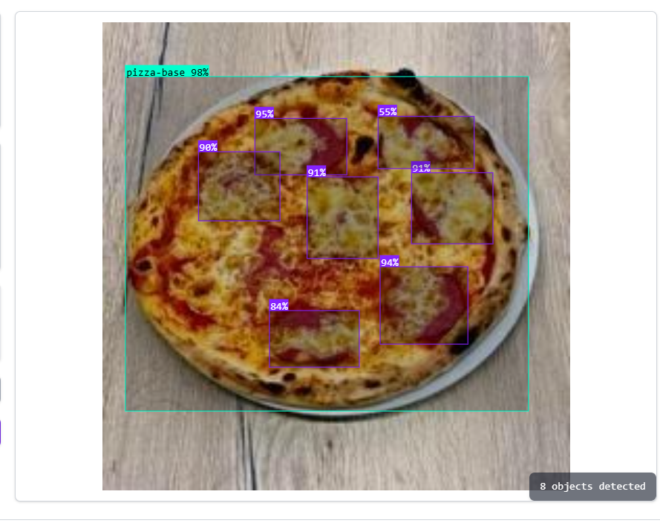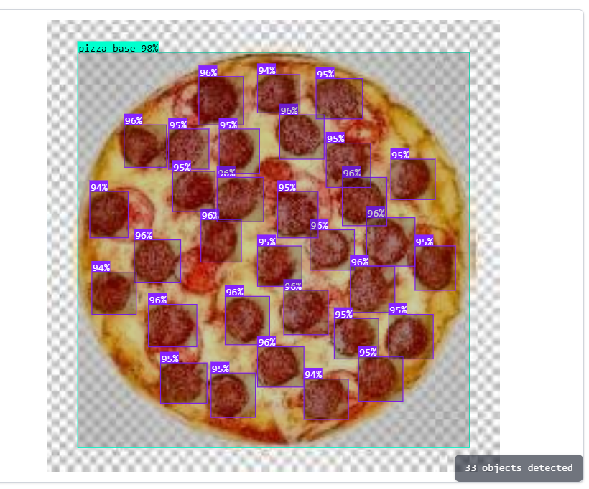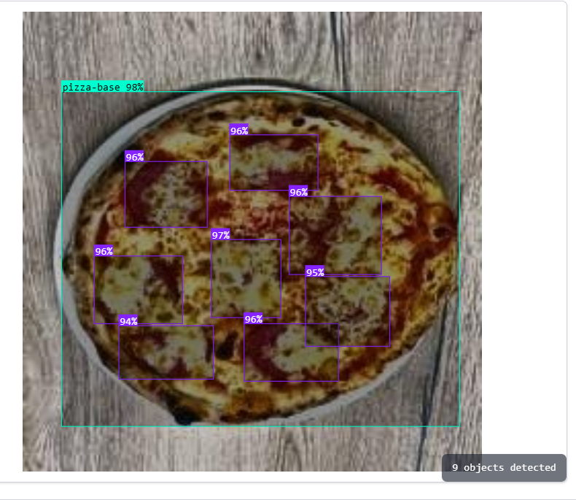

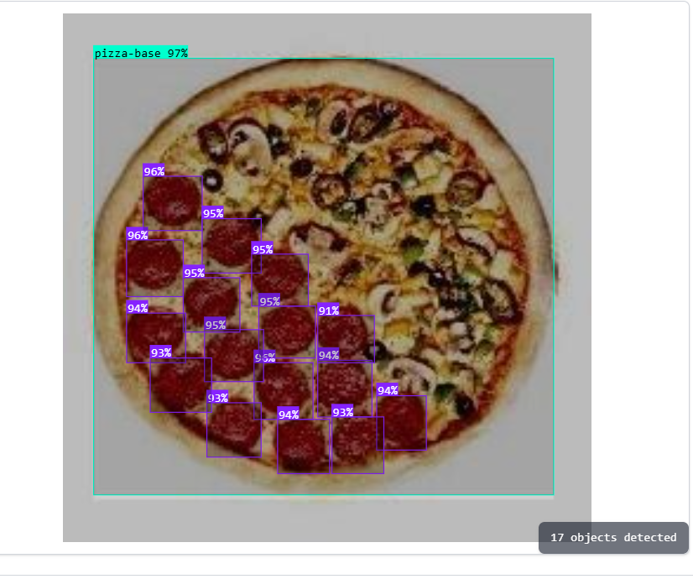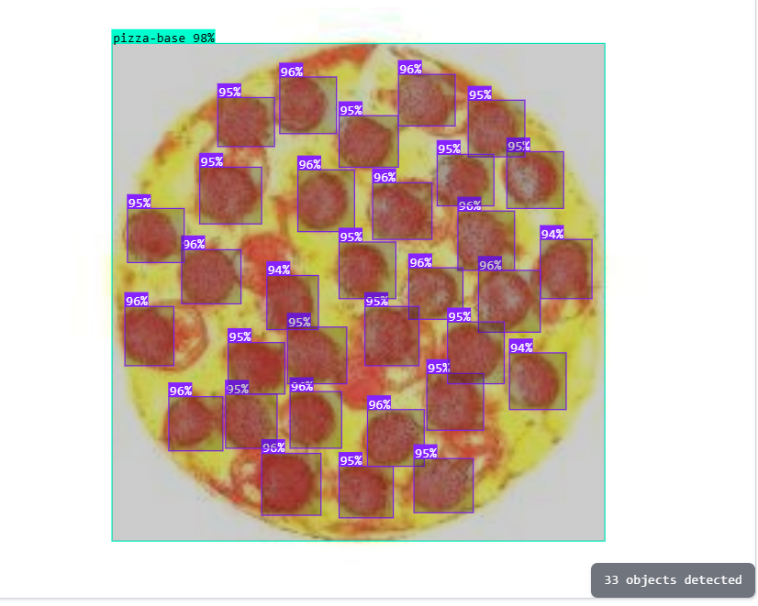

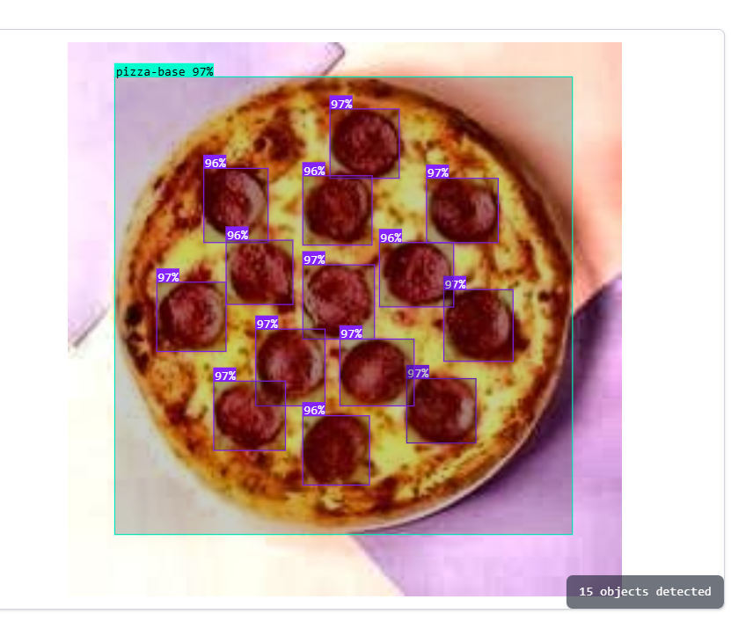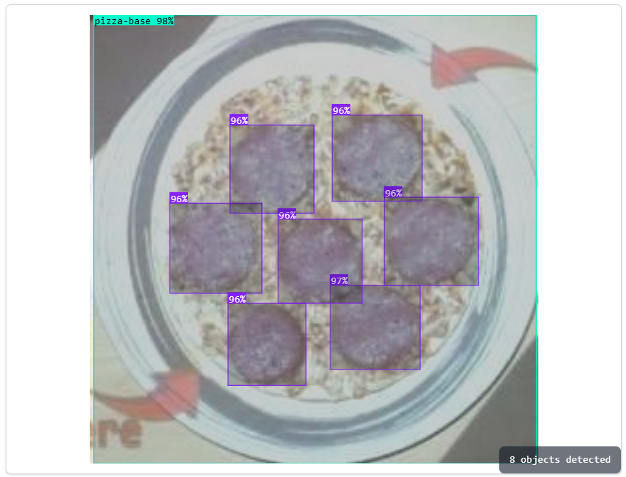

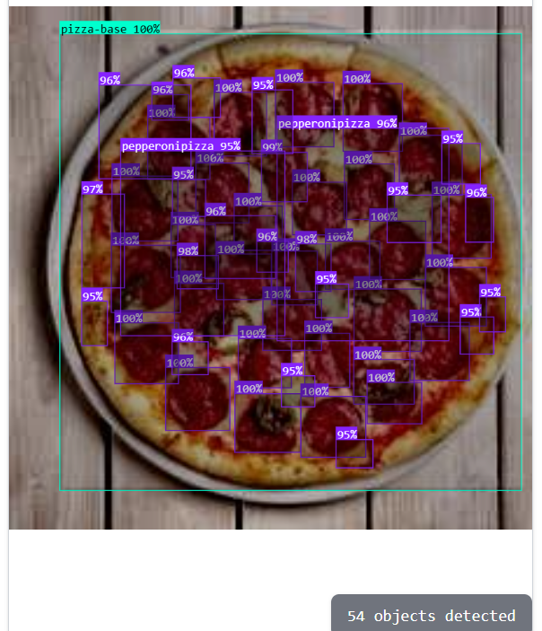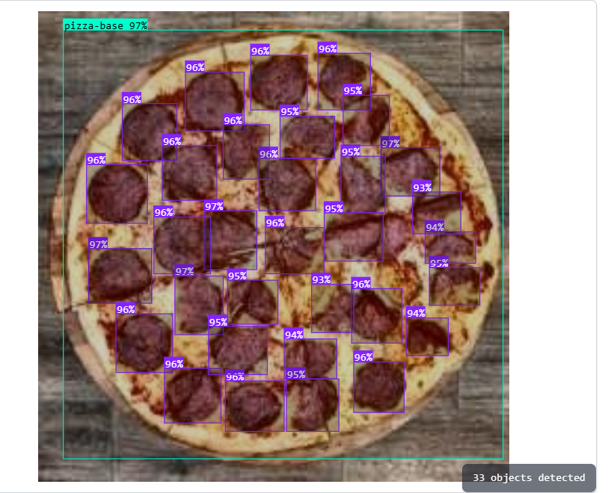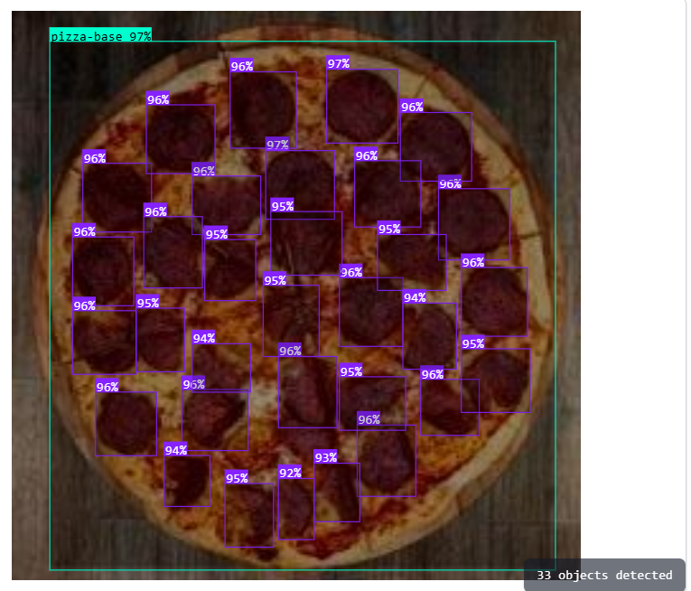

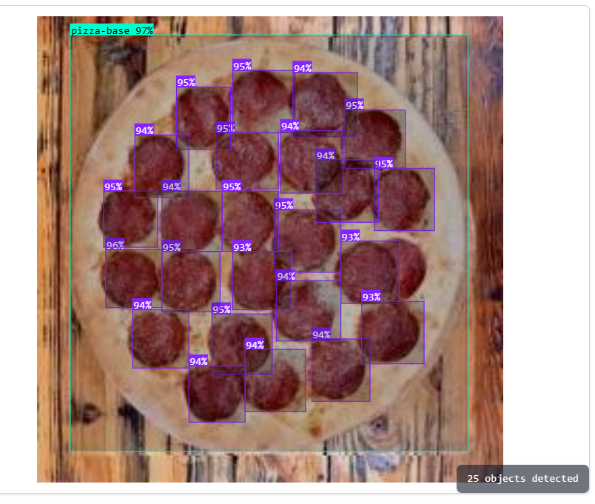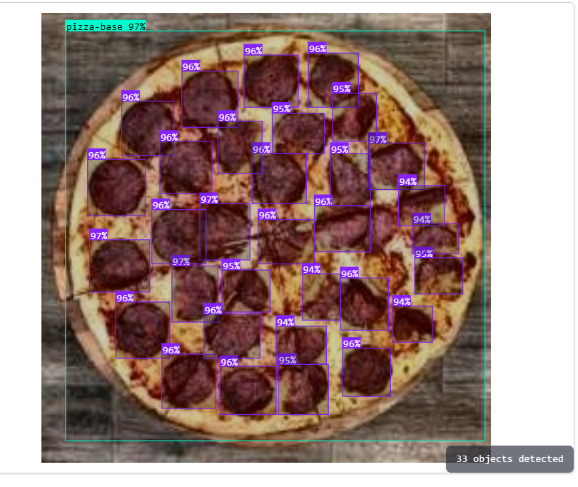

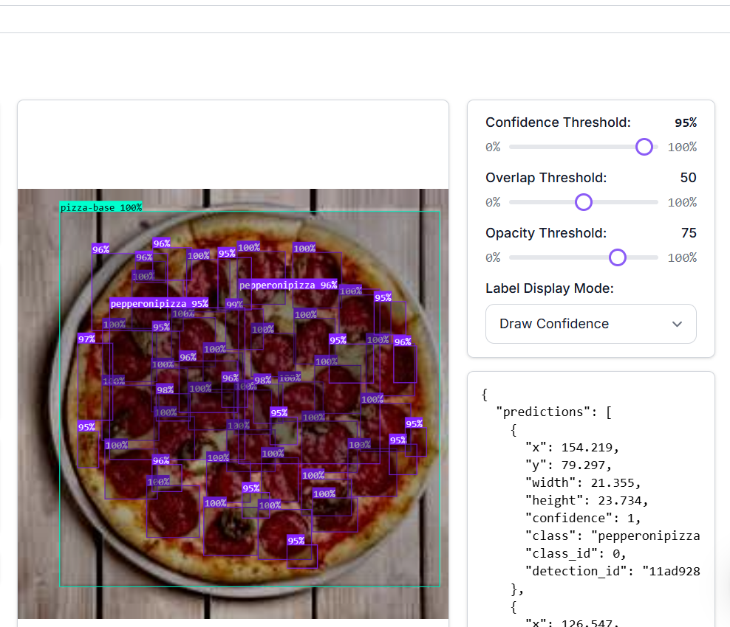

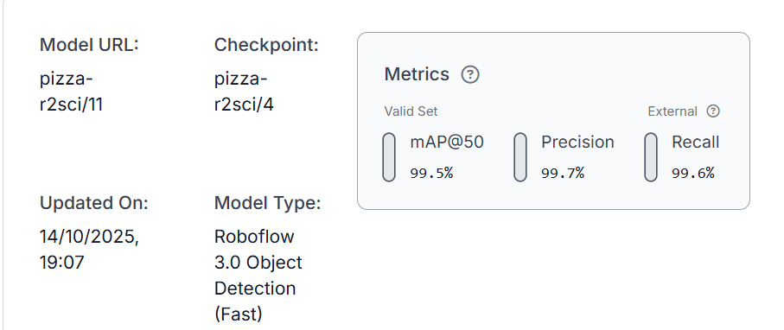

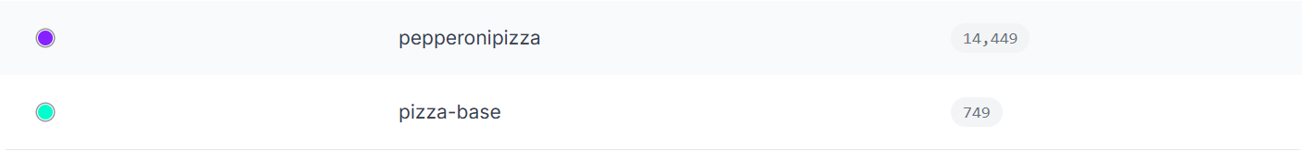

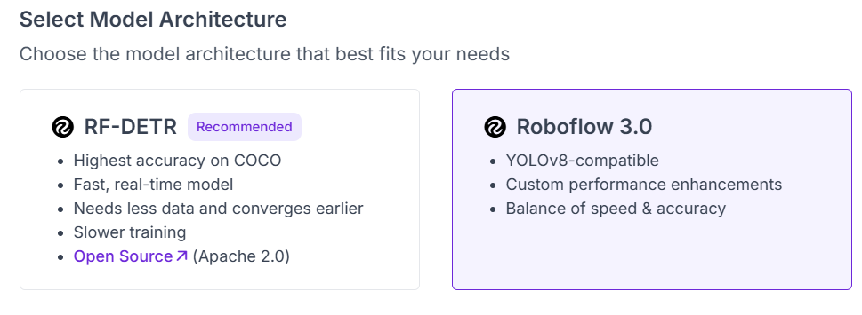

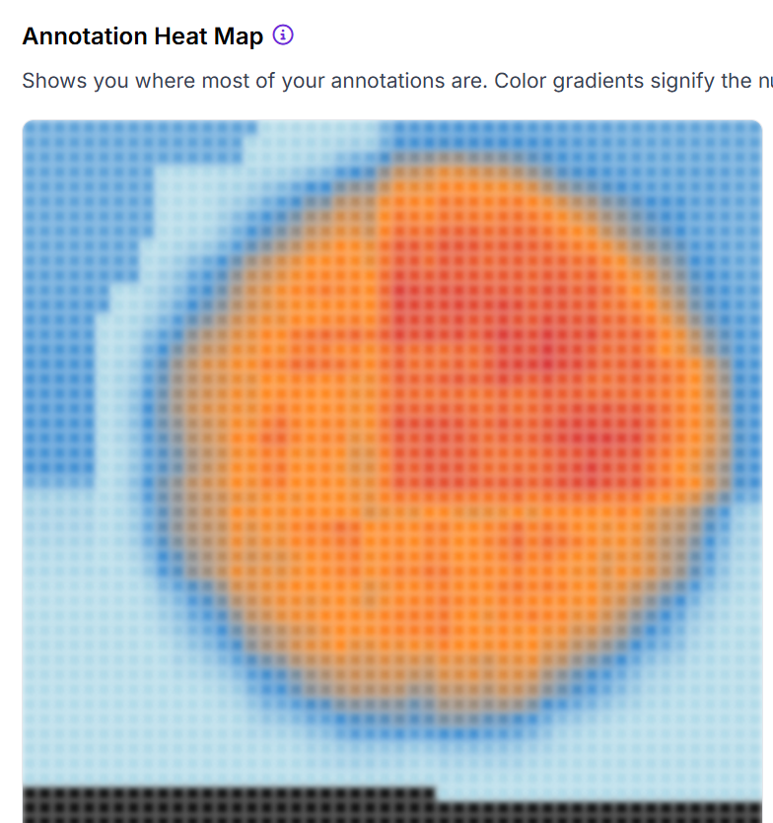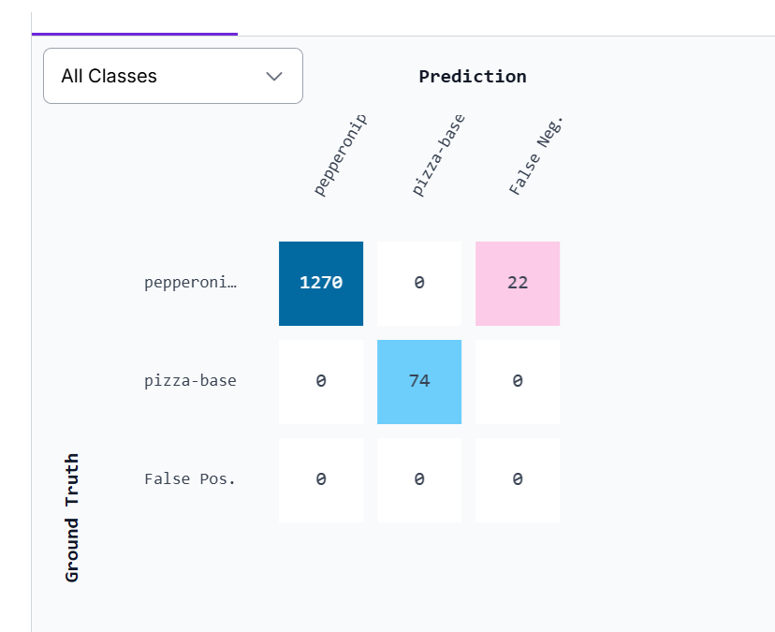

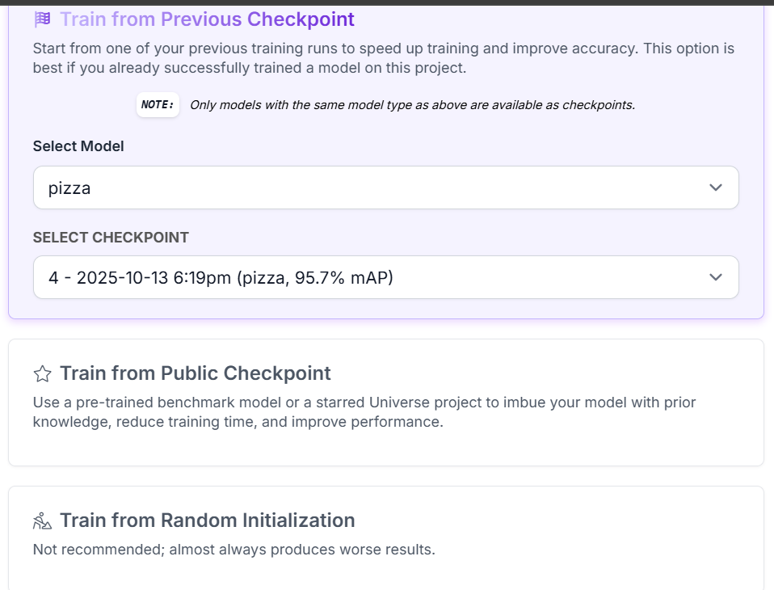

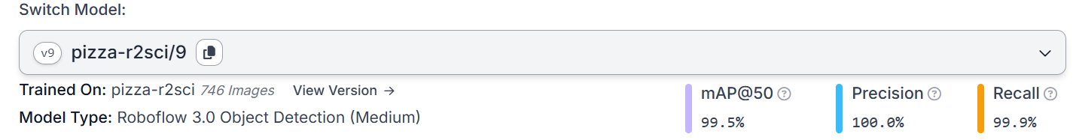

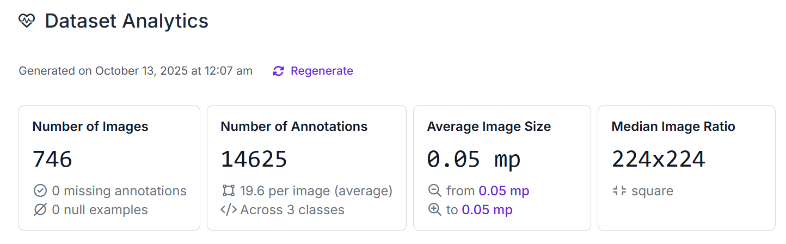

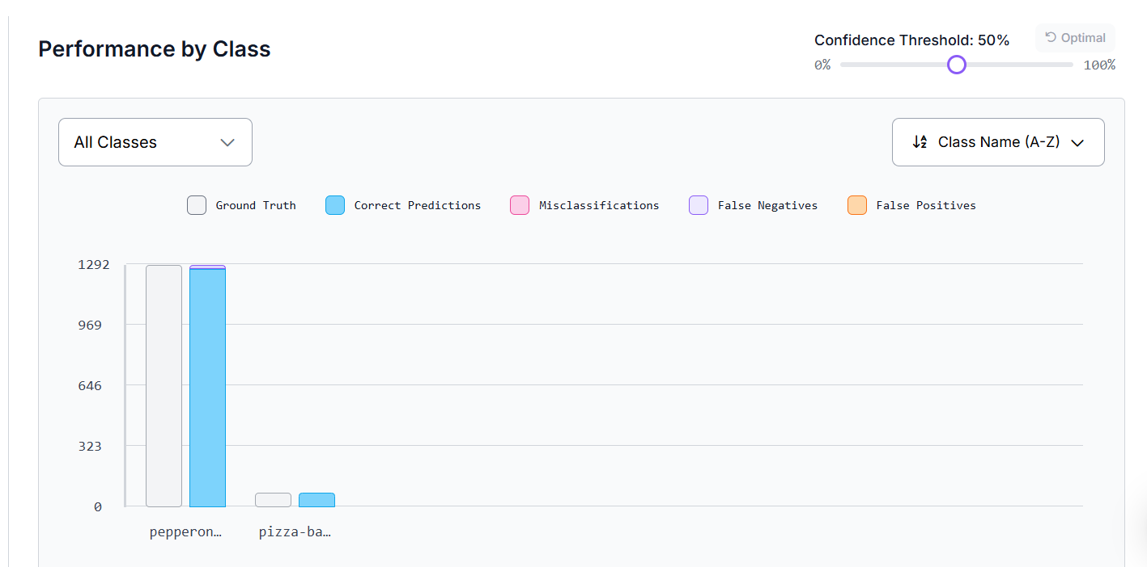

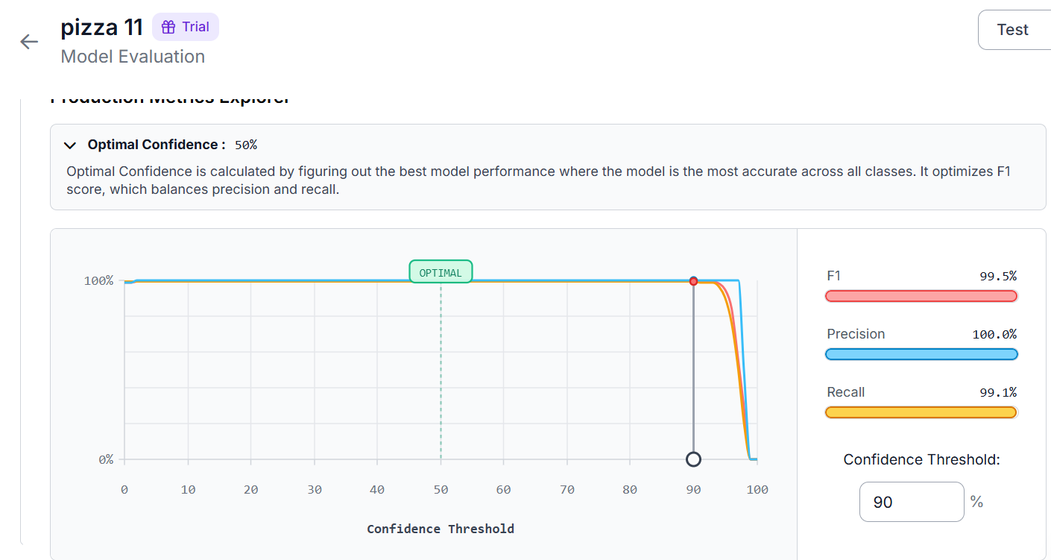

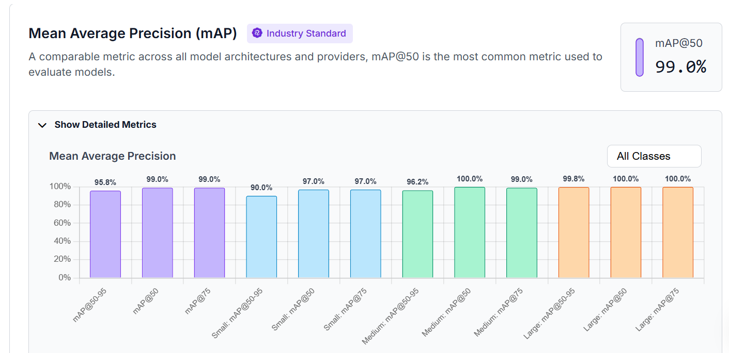

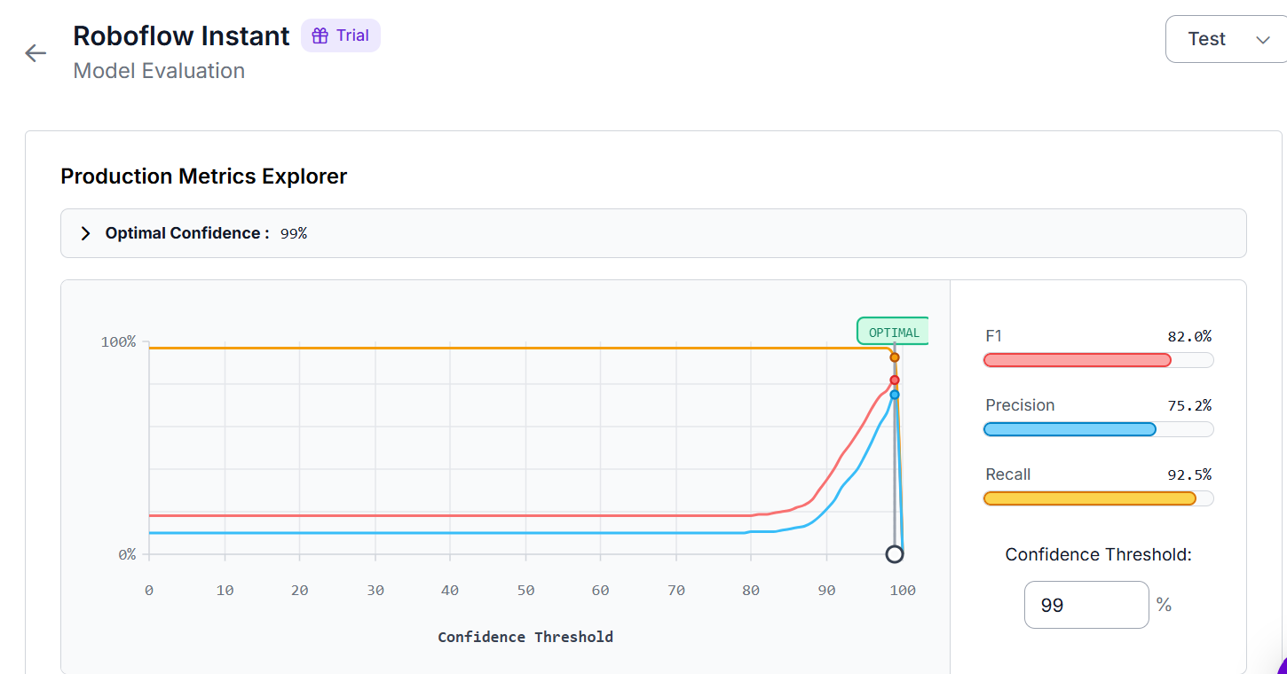

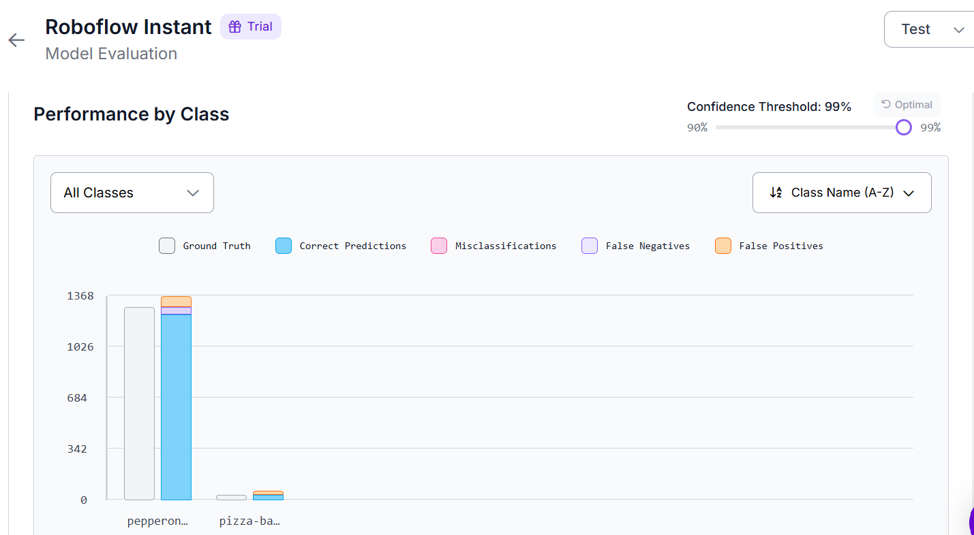

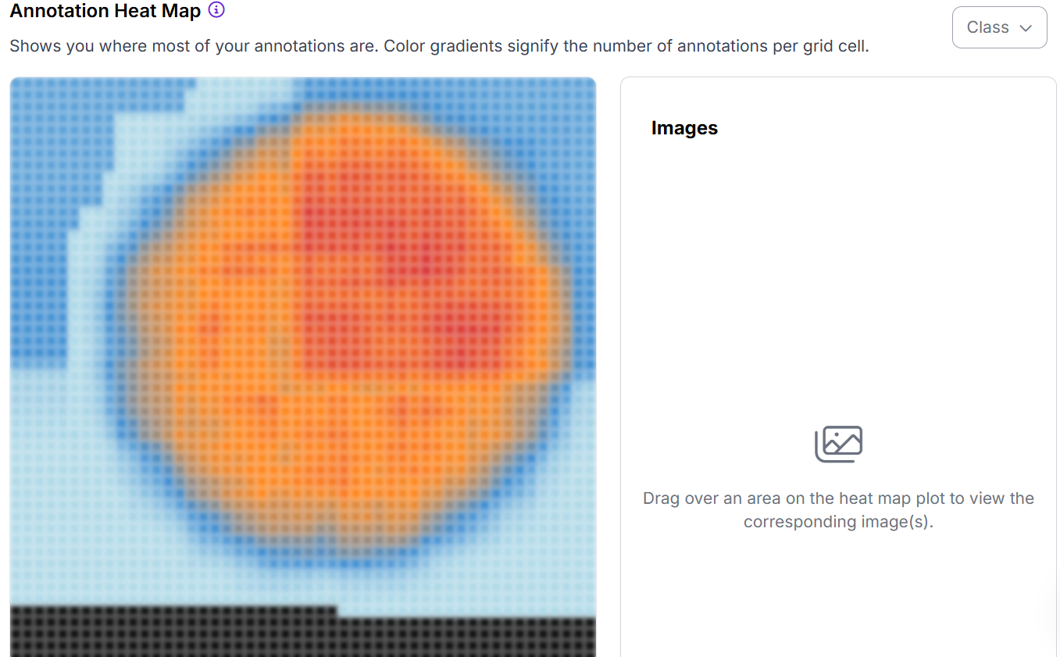

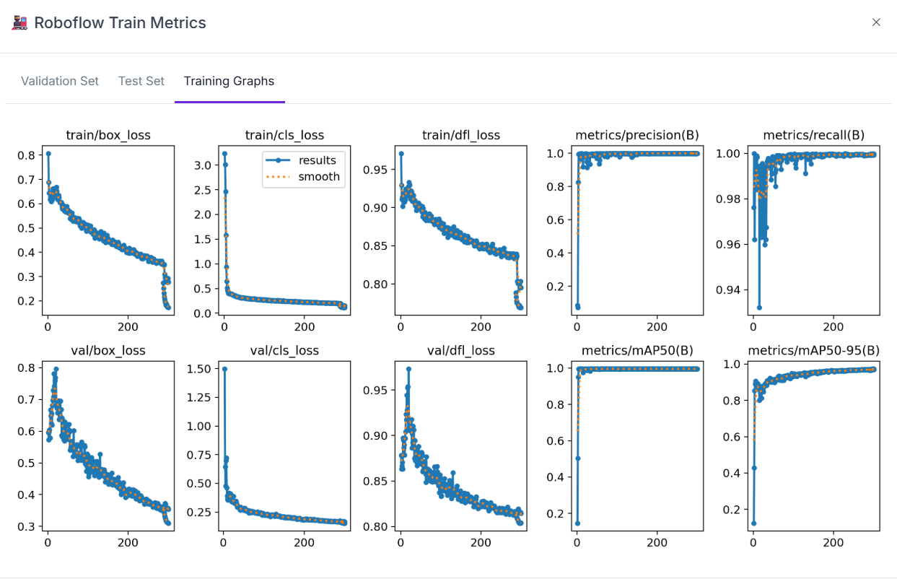

**# 🚀 Select YOLOv8 Logger**

**logger = 'TensorBoard' # options: 'TensorBoard' or 'Weights & Biases'**

**if logger == 'TensorBoard':**

**!yolo settings tensorboard=True**

**%load_ext tensorboard**

**%tensorboard --logdir runs**

**elif logger == 'Weights & Biases':**

**!yolo settings wandb=True**

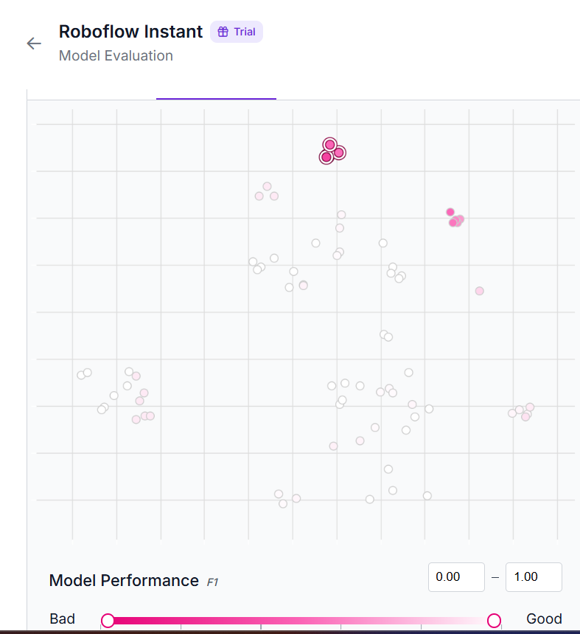

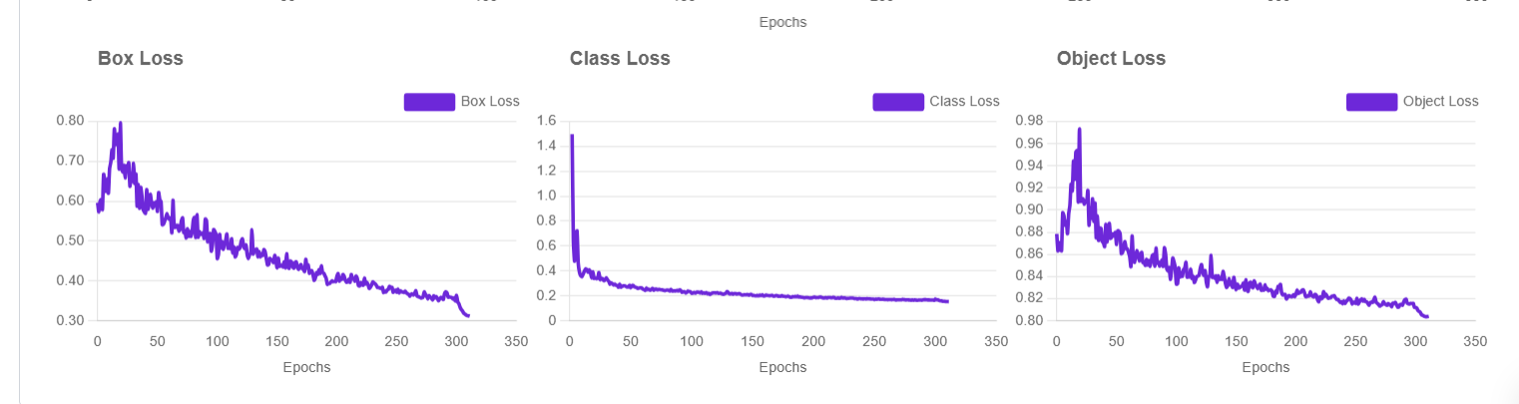

**Python code to detect pizza using pretrained yolov8n-640**

import supervision as sv

from inference import get_model

from PIL import Image

# define the image path

image_path = "/content/drive/MyDrive/pizza_35-jpg_jpg.rf.420babf22567d7db84af0a5e25942b6b.jpg"

# load the image from the file path

image = Image.open(image_path)

# load a pre-trained yolov8n model

model = get_model(model_id="yolov8n-640")

# run inference on our chosen image, image can be a url, a numpy array, a PIL image, etc.

results = model.infer(image)[0]

# load the results into the supervision Detections api

detections = sv.Detections.from_inference(results)

# create supervision annotators

bounding_box_annotator = sv.BoxAnnotator()

label_annotator = sv.LabelAnnotator()

# annotate the image with our inference results

annotated_image = bounding_box_annotator.annotate(scene=image, detections=detections)

annotated_image = label_annotator.annotate(scene=annotated_image, detections=detections)

# display the image

sv.plot_image(annotated_image)

**Results from Pretrained yolo8n-640**

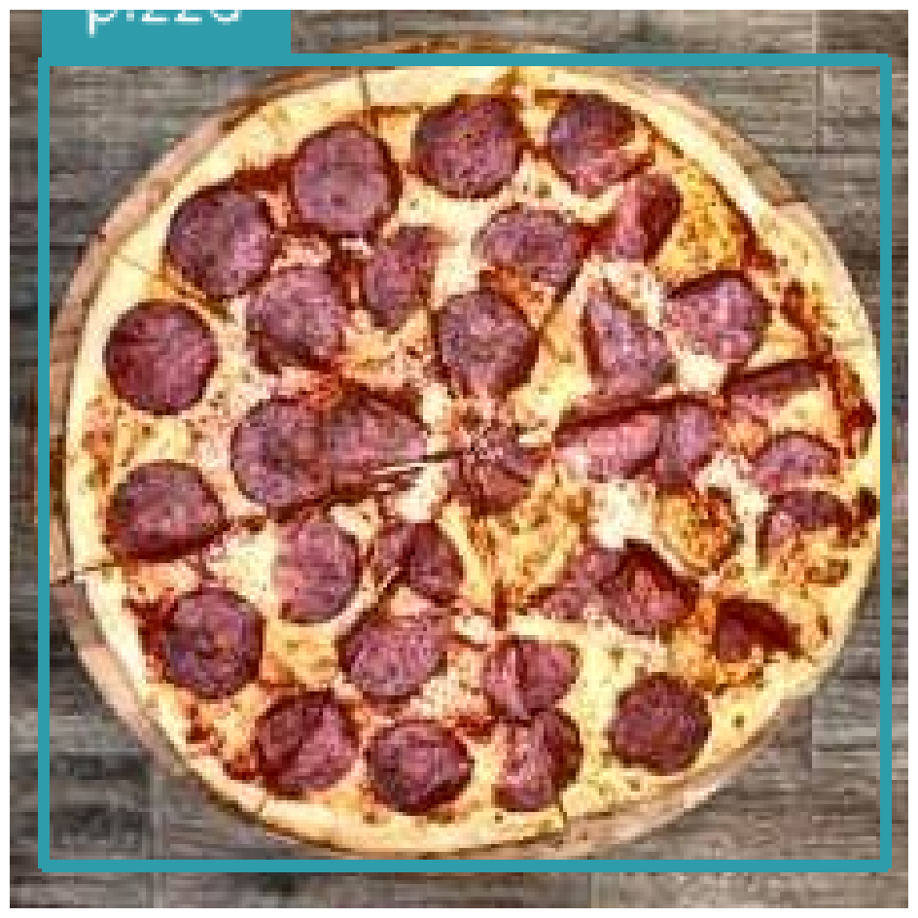**Python code to detect pizza using training of network.**

**Working Accurately.**

# Install Ultralytics if not already installed

# !pip install ultralytics  # Uncomment if needed

# For memory issues, also try: pip install torch torchvision torchaudio --index-url https://download.pytorch.org/whl/cpu

from ultralytics import YOLO

import os

import psutil  # For monitoring RAM usage; install with pip install psutil if needed

# Monitor RAM before start

print(f"Available RAM: {psutil.virtual_memory().available / (1024**3):.2f} GB")

# Load model

model = YOLO("yolov8n-seg.pt")  # Will redownload if deleted, but you have it

# Updated training parameters for low memory

train_params = {

    "data": r"C:\Users\Anam\Downloads\pizza.v9i.yolov8 (1)\data.yaml",

    "epochs": 25,

    "imgsz": 212,  # Reduced from 640 to save ~50-75% memory

    "project": r"runs\segment",

    "name": "train_pizza_lowmem",

    "batch": 1,  # Critical reduction

    "device": 'cpu',

    "workers": 1,  # Reduced to minimize multiprocessing overhead

    "cache": False,  # Avoid loading all images into RAM

    "patience": 50,  # Early stopping if no improvement

    "augment": True,  # Keep for better training, but can set False if still OOM

    "exist_ok": True  # Overwrite if rerun

}

# Start training

print("Starting training process...")

try:

    results = model.train(**train_params)

except RuntimeError as e:

    if "memory" in str(e):

        print("OOM error: Further reduce batch=1, imgsz=320, or use Google Colab (free GPU).")

    raise

# Validate

print("Validating...")

results_val = model.val()

# Dataset check (unchanged)

data_yaml = train_params["data"]

if os.path.exists(data_yaml):

    print(f"data.yaml found at {data_yaml}")

    with open(data_yaml, 'r') as f:

        content = f.read()

        print("data.yaml content preview:\n", content[:500])

else:

    print(f"Error: {data_yaml} not found.")

# Export

print("Exporting to ONNX...")

exported_model = model.export(format="onnx")

# Inference on sample

sample_image = r"C:\Users\Anam\Downloads\pizza.v9i.yolov8 (1)\test\images\pizza_28-jpg_jpg.rf.820cfa83e8886b8d7266fc1186ecb325.jpg"

if os.path.exists(sample_image):

    print("Running inference...")

    results_predict = model(sample_image)

    results_predict[0].show()

else:

    print(f"Sample image not found. List files in test/images: {os.listdir(r'C:\Users\Anam\Downloads\pizza.v9i.yolov8 (1)\test\images')[:5]}")  # Debug help

**Results from training of yolov8**

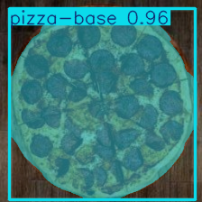

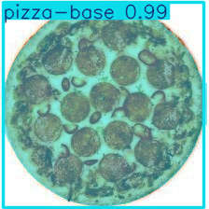

train: ../train/images

val: ../valid/images

test: ../test/images

nc: 2

names: ['pepperonipizza', 'pizza-base']

roboflow:

  workspace: anum-hup98

  project: pizza-r2sci

  version: 9

  license: CC BY 4.0

  url: https://universe.roboflow.com/anum-hup98/pizza-r2sci/dataset/9

# Install Ultralytics if not already installed

# !pip install ultralytics  # Uncomment if needed

# !pip install psutil tensorboard  # For monitoring + visualization

from ultralytics import YOLO

import os

import psutil

from datetime import datetime

# Monitor RAM before start

print(f"Available RAM: {psutil.virtual_memory().available / (1024**3):.2f} GB")

print(f"Training start time: {datetime.now().strftime('%Y-%m-%d %H:%M:%S')}")

# Load model

model = YOLO("yolov8n-seg.pt")

# 🚀 ENHANCED TRAINING PARAMETERS with TENSORBOARD LOGGING

train_params = {

    "data": r"C:\Users\Anam\Downloads\pizza.v9i.yolov8 (1)\data.yaml",

    "epochs": 20,

    "imgsz": 212,

    "project": r"runs\segment",

    "name": f"train_pizza_lowmem_tb_{datetime.now().strftime('%Y%m%d_%H%M')}",  # Unique name with timestamp

    "batch": 1,

    "device": 'cpu',

    "workers": 1,

    "cache": False,

    "patience": 50,

    "augment": True,

    "exist_ok": True,

    # 🔥 TENSORBOARD-SPECIFIC PARAMETERS (Auto-enabled!)

    "plots": True,        # Generate ALL plots automatically

    "save_period": 5,     # Save checkpoint + plots every 5 epochs

    "verbose": True,      # Detailed logging

    "save": True,         # Save best model

    "save_txt": True,     # Save labels in txt format

    # 📊 EXTRA METRICS & VISUALIZATIONS

    "save_conf": True,    # Save confidence scores

    "save_crop": True,    # Save cropped predictions

    "show_labels": True,  # Show labels in plots

    "show_conf": True,    # Show confidence in plots

}

print("🚀 Starting training with TensorBoard logging...")

print(f"📁 Logs will be saved to: {os.path.join(train_params['project'], train_params['name'])}")

print("📊 To view plots in real-time: Run `tensorboard --logdir runs` in terminal!")

try:

    results = model.train(**train_params)

    print("✅ Training completed successfully!")

except RuntimeError as e:

    if "memory" in str(e):

        print("💥 OOM error: Try imgsz=160 or Google Colab!")

    raise

# 📈 VALIDATION with plots

print("\n🔍 Validating model...")

results_val = model.val(data=train_params["data"], plots=True)

print(f"Validation mAP50: {results_val.box.map50:.3f}")

# 📁 DATASET VERIFICATION

data_yaml = train_params["data"]

if os.path.exists(data_yaml):

    print(f"\n✅ data.yaml found: {data_yaml}")

    with open(data_yaml, 'r') as f:

        content = f.read()

        print("📄 data.yaml preview:\n", content[:500])

else:

    print(f"❌ Error: {data_yaml} not found.")

# 💾 EXPORT MODEL

print("\n💾 Exporting to ONNX...")

exported_model = model.export(format="onnx")

print(f"✅ ONNX model saved!")

# 🖼️ INFERENCE ON SAMPLE

sample_image = r"C:\Users\Anam\Downloads\pizza.v9i.yolov8 (1)\test\images\pizza_28-jpg_jpg.rf.820cfa83e8886b8d7266fc1186ecb325.jpg"

test_dir = r"C:\Users\Anam\Downloads\pizza.v9i.yolov8 (1)\test\images"

if os.path.exists(sample_image):

    print(f"\n🖼️ Running inference on: {sample_image}")

    results_predict = model(sample_image, save=True, show=True)  # Auto-saves annotated image

else:

    print(f"\n❌ Sample not found. Available files:")

    files = os.listdir(test_dir)[:5]

    print(files)

    if files:

        sample_image = os.path.join(test_dir, files[0])

        print(f"🔄 Using first file: {sample_image}")

        results_predict = model(sample_image, save=True, show=True)

# 🔥 TENSORBOARD INSTRUCTIONS (PRINT THIS!)

print("\n" + "="*60)

print("🎯 TENSORBOARD - VIEW YOUR PLOTS IMMEDIATELY!")

print("="*60)

print("1. Open Terminal/Command Prompt")

print("2. Run: `tensorboard --logdir runs`")

print("3. Open browser: http://localhost:6006")

print("4. See ALL plots instantly!")

print("="*60)

print("\n📊 PLOTS YOU WILL SEE:")

print("   • 📉 Loss curves (box, cls, dfl, seg)")

print("   • 📈 mAP50/mAP50-95 curves")

print("   • 📊 Precision-Recall curves")

print("   • 🔳 Confusion Matrix")

print("   • 🖼️ Sample predictions")

print("   • 📁 Training metrics table")

print("="*60)

# 🖥️ QUICK PLOT GENERATION (Alternative to TensorBoard)

print("\n🖼️ Generating static plots too...")

results.show()  # Show training results

results_val.show()  # Show validation plots

# Install Ultralytics if not already installed

# !pip install ultralytics  # Uncomment if needed

# !pip install psutil tensorboard  # For monitoring + visualization

from ultralytics import YOLO

import os

import psutil

from datetime import datetime

# Monitor RAM before start

print(f"Available RAM: {psutil.virtual_memory().available / (1024**3):.2f} GB")

print(f"Training start time: {datetime.now().strftime('%Y-%m-%d %H:%M:%S')}")

# Load model

model = YOLO("yolov8n-seg.pt")

# 🚀 ENHANCED TRAINING PARAMETERS with TENSORBOARD LOGGING

train_params = {

    "data": r"C:\Users\Anam\Downloads\pizza.v9i.yolov8 (1)\data.yaml",

    "epochs": 20,

    "imgsz": 212,

    "project": r"runs\segment",

    "name": f"train_pizza_lowmem_tb_{datetime.now().strftime('%Y%m%d_%H%M')}",  # Unique name with timestamp

    "batch": 1,

    "device": 'cpu',

    "workers": 1,

    "cache": False,

    "patience": 50,

    "augment": True,

    "exist_ok": True,

    # 🔥 TENSORBOARD-SPECIFIC PARAMETERS (Auto-enabled!)

    "plots": True,        # Generate ALL plots automatically

    "save_period": 5,     # Save checkpoint + plots every 5 epochs

    "verbose": True,      # Detailed logging

    "save": True,         # Save best model

    "save_txt": True,     # Save labels in txt format

    # 📊 EXTRA METRICS & VISUALIZATIONS

    "save_conf": True,    # Save confidence scores

    "save_crop": True,    # Save cropped predictions

    "show_labels": True,  # Show labels in plots

    "show_conf": True,    # Show confidence in plots

}

print("🚀 Starting training with TensorBoard logging...")

print(f"📁 Logs will be saved to: {os.path.join(train_params['project'], train_params['name'])}")

print("📊 To view plots in real-time: Run `tensorboard --logdir runs` in terminal!")

try:

    results = model.train(**train_params)

    print("✅ Training completed successfully!")

except RuntimeError as e:

    if "memory" in str(e):

        print("💥 OOM error: Try imgsz=160 or Google Colab!")

    raise

# 📈 VALIDATION with plots

print("\n🔍 Validating model...")

results_val = model.val(data=train_params["data"], plots=True)

print(f"Validation mAP50: {results_val.box.map50:.3f}")

# 📁 DATASET VERIFICATION

data_yaml = train_params["data"]

if os.path.exists(data_yaml):

    print(f"\n✅ data.yaml found: {data_yaml}")

    with open(data_yaml, 'r') as f:

        content = f.read()

        print("📄 data.yaml preview:\n", content[:500])

else:

    print(f"❌ Error: {data_yaml} not found.")

# 💾 EXPORT MODEL

print("\n💾 Exporting to ONNX...")

exported_model = model.export(format="onnx")

print(f"✅ ONNX model saved!")

# 🖼️ INFERENCE ON SAMPLE

sample_image = r"C:\Users\Anam\Downloads\pizza.v9i.yolov8 (1)\test\images\pizza_28-jpg_jpg.rf.820cfa83e8886b8d7266fc1186ecb325.jpg"

test_dir = r"C:\Users\Anam\Downloads\pizza.v9i.yolov8 (1)\test\images"

if os.path.exists(sample_image):

    print(f"\n🖼️ Running inference on: {sample_image}")

    results_predict = model(sample_image, save=True, show=True)  # Auto-saves annotated image

else:

    print(f"\n❌ Sample not found. Available files:")

    files = os.listdir(test_dir)[:5]

    print(files)

    if files:

        sample_image = os.path.join(test_dir, files[0])

        print(f"🔄 Using first file: {sample_image}")

        results_predict = model(sample_image, save=True, show=True)

# 🔥 TENSORBOARD INSTRUCTIONS (PRINT THIS!)

print("\n" + "="*60)

print("🎯 TENSORBOARD - VIEW YOUR PLOTS IMMEDIATELY!")

print("="*60)

print("1. Open Terminal/Command Prompt")

print("2. Run: `tensorboard --logdir runs`")

print("3. Open browser: http://localhost:6006")

print("4. See ALL plots instantly!")

print("="*60)

print("\n📊 PLOTS YOU WILL SEE:")

print("   • 📉 Loss curves (box, cls, dfl, seg)")

print("   • 📈 mAP50/mAP50-95 curves")

print("   • 📊 Precision-Recall curves")

print("   • 🔳 Confusion Matrix")

print("   • 🖼️ Sample predictions")

print("   • 📁 Training metrics table")

print("="*60)

# 🖥️ QUICK PLOT GENERATION (Alternative to TensorBoard)

print("\n🖼️ Generating static plots too...")

results.show()  # Show training results

results_val.show()  # Show validation plots

**Pizza making steps in short:**

* **Dough cutting process**
* **Flavoring**
* **Pressing**
* **Precesion pressing mechanism**
* **Dough into sheets**
* **Dough into desired shape**
* **Dough uniform size ,shape entire batch**
* **High volume production**
* **Pizza topping**
* **Specialized rolling machine**
* **Topping on sauced bases**
* **Every pizza perceives perfect topping on base**
* **cheese topping**

**precise amount of cheese**

**pizza freezing,,,**

**freezing to preserve life**

**some are few cooked**

**passed through conveyers belts**

**automated cartoon eracted machines**

**Pizza Making Steps in High-Volume Production**

High-volume pizza production involves automated processes to ensure consistency, speed, and quality across large batches. This is common in industrial settings like frozen pizza factories. Below, I'll outline the key steps, incorporating the specific elements you mentioned (e.g., dough handling, flavoring, pressing, topping, freezing). The process uses specialized machinery like conveyors, rollers, and automated dispensers for efficiency.

1. Dough Preparation and Initial Mixing

Ingredients (flour, water, yeast, salt, oil) are mixed in large industrial mixers to form dough.

The dough is kneaded automatically and allowed to rise (proof) in controlled environments for consistent texture.

Flavoring: Additives like herbs, garlic, or cheese flavors are incorporated during mixing for flavored crusts. This ensures even distribution across the batch.

**2. Dough Division and Cutting Process**

Dough cutting process: The risen dough is fed into a divider machine that cuts it into uniform portions using blades or extruders.

Dough uniform size, shape entire batch: Automated dividers use weight sensors and volumetric controls to ensure every piece is identical (e.g., 200g balls). This precision maintains consistency for the whole batch, reducing waste in high-volume runs (thousands per hour).

**3. Dough Shaping and Sheeting**

Dough into sheets: Portions are flattened into sheets using a sheeter machine, which rolls dough between conveyor belts.

Specialized rolling machine: Heavy-duty rollers (often with adjustable gaps) process dough at high speeds, handling multiple sheets simultaneously.

Dough into desired shape: After sheeting, hydraulic cutters or dies stamp out rounds, squares, or custom shapes (e.g., 12-inch circles).

Pressing and precision pressing mechanism:

Initial pressing flattens dough balls via pneumatic presses.

Precision pressing mechanism: Uses servo-controlled hydraulic or mechanical arms with sensors for exact pressure (e.g., 5-10 tons) and thickness (2-5mm). This avoids air pockets and ensures uniformity, critical for even baking in large batches.

**4. Sauce Application**

**Shaped dough bases move via conveyor belts to a saucing station.**

**Automated dispensers apply tomato sauce evenly using spinning discs or nozzles, ensuring full coverage without overflow.**

**5. Pizza Topping Application**

Topping on sauced bases: Bases pass under topping stations on conveyors.

Every pizza perceives perfect topping on base: Vision systems (cameras) and AI-guided robots inspect and adjust placements in real-time for visual perfection—e.g., even spacing of pepperoni slices.

Ingredients like meats, veggies, and olives are dispensed via vibrating feeders or waterfall applicators for high-volume output (up to 10,000 pizzas/hour).

Cheese topping and precise amount of cheese: Shredded cheese is applied last using volumetric augers or air-blown dispensers. Scales and sensors meter exact amounts (e.g., 100g per pizza) for consistency and cost control.

**6. Partial Cooking (Optional)**

Some are few cooked: In some lines, pizzas are par-baked (partially cooked) in tunnel ovens at 200-300°C for 1-2 minutes to set the crust and toppings. This step is skipped for fully raw frozen pizzas but helps with texture in others.

7. Freezing and Preservation

Pizza freezing: Assembled pizzas pass through spiral or tunnel freezers on conveyor belts, blast-chilled with -40°C air or liquid nitrogen to freeze in 10-20 minutes.

Freezing to preserve life: Rapid freezing locks in freshness, prevents bacterial growth, and extends shelf life up to 12 months. Individually quick-frozen (IQF) methods ensure toppings don't clump.

**8. Packaging and Cartoning**

Automated cartoner erected machines: Frozen pizzas are wrapped in film, then fed into robotic cartoners. These machines erect boxes from flats, insert pizzas (often with trays), seal, and label them automatically. Metal detectors and check-weighers ensure quality before palletizing.

# Install required libraries

!pip install pytube moviepy

from pytube import YouTube

from moviepy.editor import VideoFileClip

import os

# Download YouTube video

url = "https://www.youtube.com/watch?v=5lKsyMu6pAk"

yt = YouTube(url)

video_stream = yt.streams.filter(file_extension='mp4', progressive=True).first()

video_path = video_stream.download(output_path=".")

print(f"Downloaded video: {video_path}")

# Extract 1-minute clip (e.g., from 1:00 to 2:00)

output_clip_path = "pizza_clip_1min.mp4"

video = VideoFileClip(video_path)

clip = video.subclip(60, 120) # Extract from 1:00 to 2:00

clip.write_videofile(output_clip_path, codec="libx264")

clip.close()

video.close()

print(f"1-minute clip saved as: {output_clip_path}")

**python code to predict pizza in one minute video frame**

**I extract images as frame from video.**

**Python code which worked accurately for detecting pizza in frames of video.I extracted images from 1 min video frame and performed detection on it.**

import os

import cv2

from ultralytics import YOLO

# ✅ 1. Load Model (change to "best.pt" if you trained your own)

model = YOLO("yolov8n.pt")

# ✅ 2. Folder containing your images

input_folder = "/content/drive/MyDrive/videos-frames"  # change if needed

output_folder = "/content/drive/MyDrive/output"

os.makedirs(output_folder, exist_ok=True)

# ✅ 3. Loop through all image files

valid_exts = ('.png', '.jpg', '.jpeg', '.bmp')

image_files = [f for f in os.listdir(input_folder) if f.lower().endswith(valid_exts)]

print(f"✅ Found {len(image_files)} images. Starting detection...")

for idx, filename in enumerate(image_files, start=1):

    image_path = os.path.join(input_folder, filename)

    # Run YOLO detection

    results = model.predict(image_path, conf=0.25, stream=False)

    # Annotate and save the output

    annotated = results[0].plot()  # draw bounding boxes

    out_name = f"detected_{filename}"

    out_path = os.path.join(output_folder, out_name)

    cv2.imwrite(out_path, annotated)

    print(f"[{idx}/{len(image_files)}] ✅ Saved: {out_path}")

print("\n🎉 All images processed!")

print(f"✅ Annotated results saved in: {output_folder}")

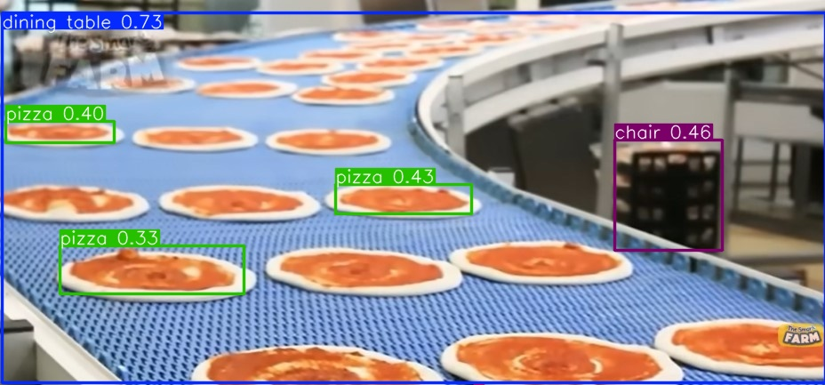

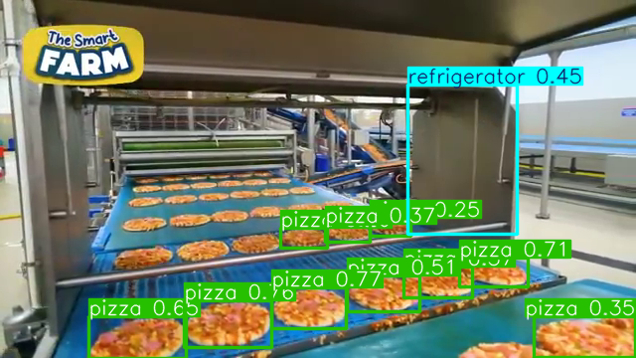

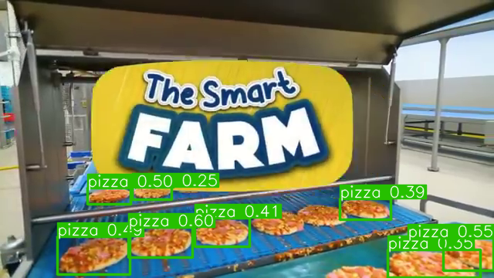



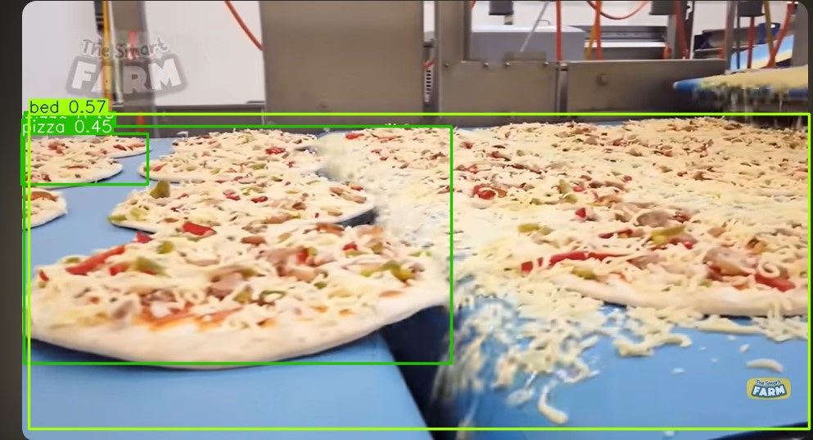



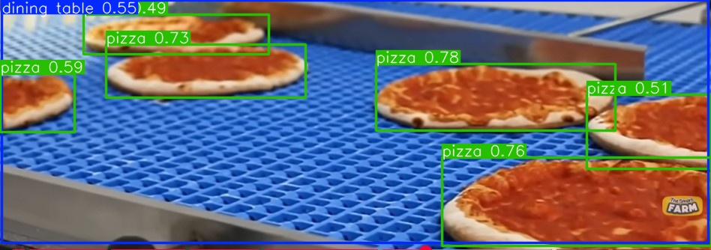

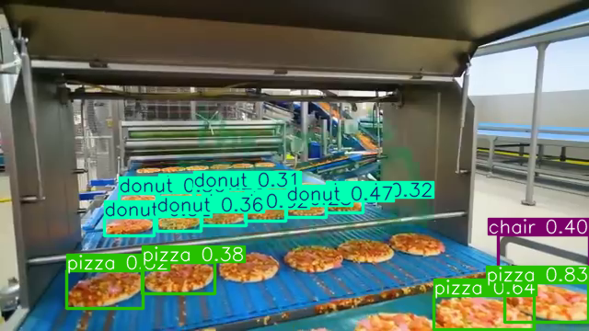

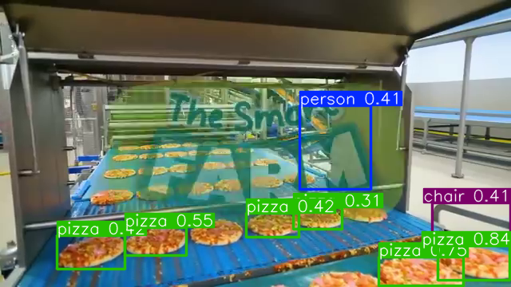

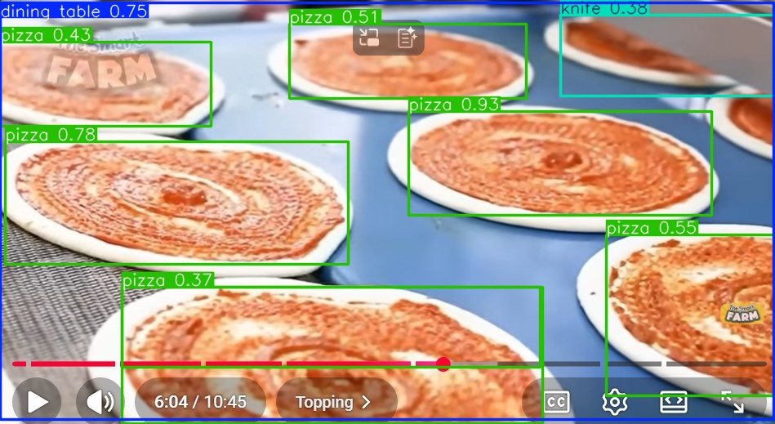



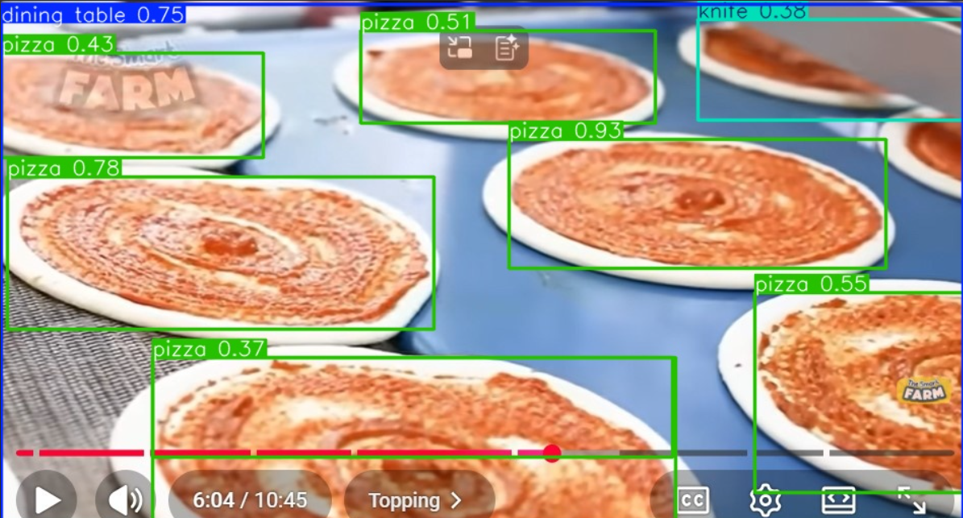

import os

import cv2

from ultralytics import YOLO

# ✅ 1. Load Model (change to "best.pt" if you trained your own)

model = YOLO("yolov8n.pt")

# ✅ 2. Folder containing your images

input_folder = "/content/drive/MyDrive/videos-frames"  # change if needed

output_folder = "/content/drive/MyDrive/output"

os.makedirs(output_folder, exist_ok=True)

# ✅ 3. Loop through all image files

valid_exts = ('.png', '.jpg', '.jpeg', '.bmp')

image_files = [f for f in os.listdir(input_folder) if f.lower().endswith(valid_exts)]

print(f"✅ Found {len(image_files)} images. Starting detection...")

for idx, filename in enumerate(image_files, start=1):

    image_path = os.path.join(input_folder, filename)

    # Run YOLO detection

    results = model.predict(image_path, conf=0.25, stream=False)

    # Annotate and save the output

    annotated = results[0].plot()  # draw bounding boxes

    out_name = f"detected_{filename}"

    out_path = os.path.join(output_folder, out_name)

    cv2.imwrite(out_path, annotated)

    print(f"[{idx}/{len(image_files)}] ✅ Saved: {out_path}")

print("\n🎉 All images processed!")

print(f"✅ Annotated results saved in: {output_folder}")

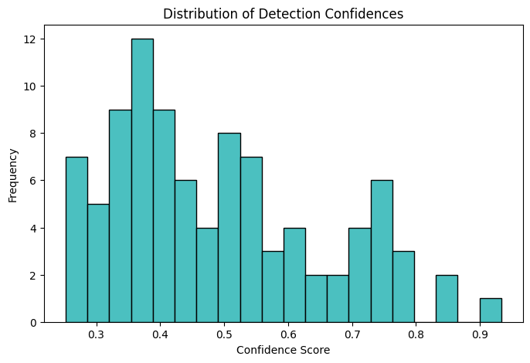

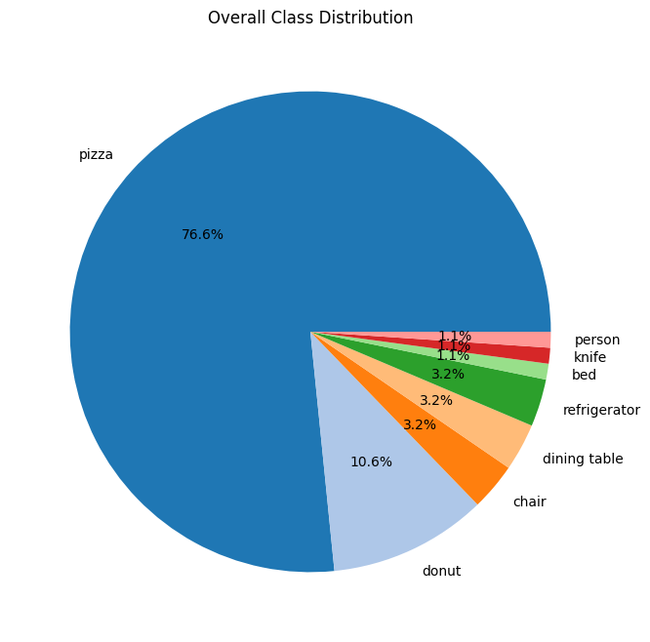

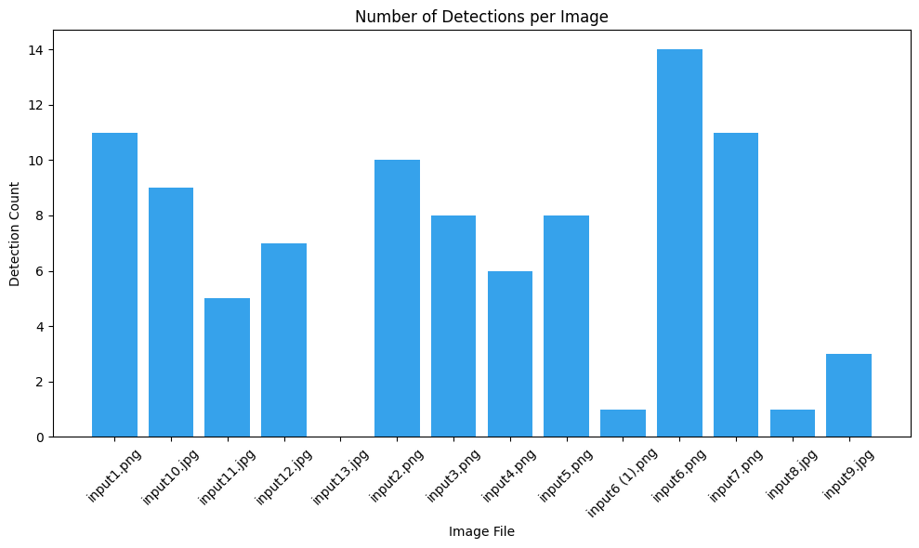

import os

**Code for plots**

import pandas as pd

import matplotlib.pyplot as plt

from ultralytics import YOLO

from collections import defaultdict

# Load model again (for extraction)

model = YOLO("yolov8n.pt")

# Input/Output folders (same as before)

input_folder = "/content/drive/MyDrive/videos-frames"

output_folder = "/content/drive/MyDrive/output"

valid_exts = ('.png', '.jpg', '.jpeg', '.bmp')

# Get sorted image files (ensure order matches saved outputs)

image_files = sorted([f for f in os.listdir(input_folder) if f.lower().endswith(valid_exts)])

output_files = sorted([f for f in os.listdir(output_folder) if f.startswith('detected_')])

print(f"✅ Analyzing {len(image_files)} processed images...")

# Collect data

data = []

class_counts = defaultdict(int)

confidences = []

for idx, filename in enumerate(image_files):

    image_path = os.path.join(input_folder, filename)

    results = model.predict(image_path, conf=0.25, stream=False)[0]  # Re-infer for metrics

    boxes = results.boxes

    num_dets = len(boxes) if boxes is not None else 0

    avg_conf = boxes.conf.mean().item() if num_dets > 0 else 0

    confidences.extend(boxes.conf.tolist() if num_dets > 0 else [])

    for cls_id in boxes.cls.tolist():

        class_name = results.names[int(cls_id)]

        class_counts[class_name] += 1

    data.append({

        'image': filename,

        'detections': num_dets,

        'avg_confidence': avg_conf

    })

    print(f"[{idx+1}/{len(image_files)}] {filename}: {num_dets} detections, avg conf {avg_conf:.2f}")

# Save summary CSV

df = pd.DataFrame(data)

summary_path = os.path.join(output_folder, 'detection_summary.csv')

df.to_csv(summary_path, index=False)

print(f"\n✅ Summary saved to: {summary_path}")

# Class distribution

class_df = pd.DataFrame.from_dict(class_counts, orient='index', columns=['count']).sort_values('count', ascending=False)

# Plot 1: Detections per Image (Bar Chart)

plt.figure(figsize=(10, 6))

plt.bar(df['image'], df['detections'], color='#36A2EB')

plt.title('Number of Detections per Image')

plt.xlabel('Image File')

plt.ylabel('Detection Count')

plt.xticks(rotation=45)

plt.tight_layout()

plt.savefig(os.path.join(output_folder, 'detections_per_image.png'))

plt.show()

# Plot 2: Average Confidence per Image (Line Chart)

plt.figure(figsize=(10, 6))

plt.plot(df['image'], df['avg_confidence'], marker='o', color='#FF6384')

plt.title('Average Confidence per Image')

plt.xlabel('Image File')

plt.ylabel('Avg Confidence')

plt.xticks(rotation=45)

plt.tight_layout()

plt.savefig(os.path.join(output_folder, 'avg_conf_per_image.png'))

plt.show()

# Plot 3: Class Distribution (Pie Chart)

if not class_df.empty:

    plt.figure(figsize=(8, 8))

    plt.pie(class_df['count'], labels=class_df.index, autopct='%1.1f%%', colors=plt.cm.tab20.colors)

    plt.title('Overall Class Distribution')

    plt.savefig(os.path.join(output_folder, 'class_distribution.png'))

    plt.show()

# Plot 4: Confidence Histogram

plt.figure(figsize=(8, 5))

plt.hist(confidences, bins=20, color='#4BC0C0', edgecolor='black')

plt.title('Distribution of Detection Confidences')

plt.xlabel('Confidence Score')

plt.ylabel('Frequency')

plt.savefig(os.path.join(output_folder, 'confidence_hist.png'))

plt.show()

print("\n🎉 Plots saved in output folder!")

print(" - detections_per_image.png")

print(" - avg_conf_per_image.png")

print(" - class_distribution.png")

print(" - confidence_hist.png")

